Below are the screenshots of the output:

Creating the customer and viewing the details

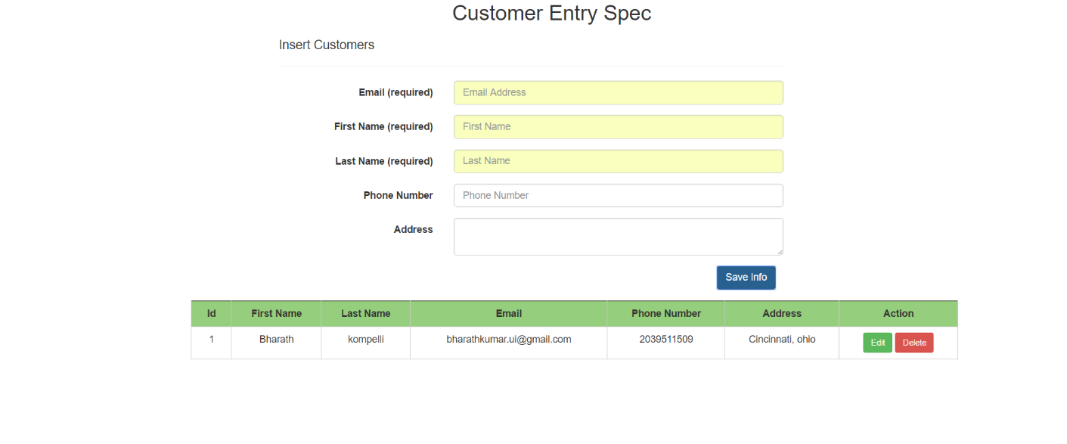

Editing the Customer Details

